**Assignment – 3**

**Core HTML**

1. 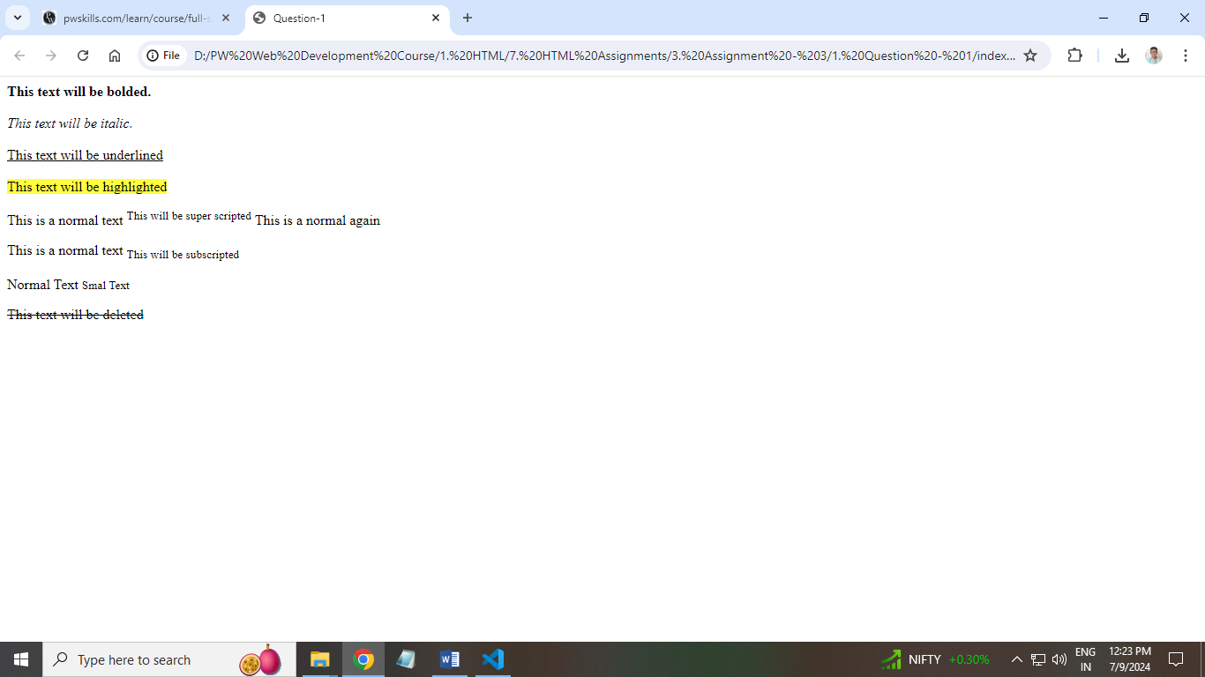**Build a simple webpage that displays text as shown in the below image.**

**Ans: HTML Code:**

**<!DOCTYPE html>**

**<html lang="en">**

**<head>**

**<meta charset="UTF-8">**

**<meta name="viewport" content="width=device-width, initial-scale=1.0">**

**<title>Question-1</title>**

**</head>**

**<body>**

**<!-- Use of bold tag to bold the text -->**

**<b>This text will be bolded.</b> <br> <br>**

**<!-- Use of italic tag to italicize the text -->**

**<i>This text will be italic.</i> <br> <br>**

**<! -- Usage of underline tag to underline the text -->**

**<u>This text will be underlined</u> <br> <br>**

**<! -- Use of mark tag to highlight the text -->**

**<mark>This text will be highlighted</mark>**

**<! -- Use of superscript tags to add superscript text -->**

**<p>This is a normal text <sup>This will be super scripted</sup> This is a normal again</p>**

**<! -- Use of subscript tags to add subscript text -->**

**<p>This is a normal text <sub>This will be subscripted</sub></p>**

**<! -- Use of small tag to make the text smaller -->**

**<p>Normal Text <small>Smal Text</small></p>**

**<! -- Use of del tag to delete the text -->**

**<del>This text will be deleted</del>**

**</body>**

**</html>**

1. **Build a simple webpage that helps users navigate different web development-related websites.**

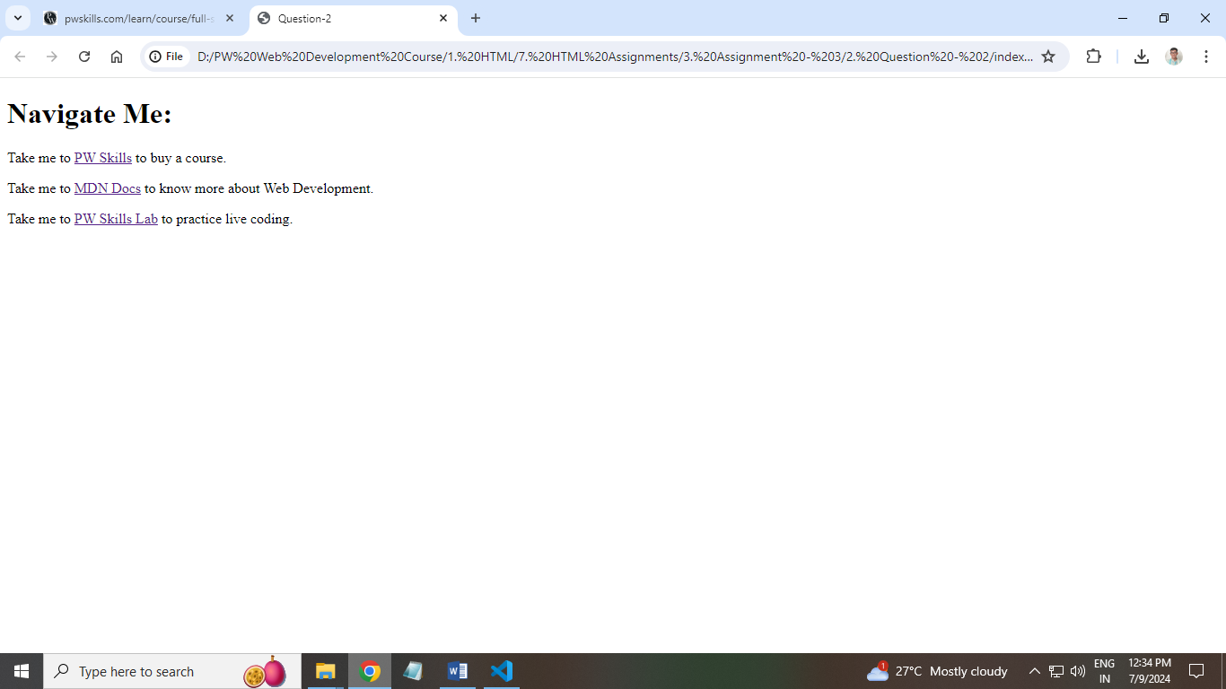**Ans: HTML Code:**

**<!DOCTYPE html>**

**<html lang="en">**

**<head>**

**<meta charset="UTF-8">**

**<meta name="viewport" content="width=device-width, initial-scale=1.0">**

**<title>Question-2</title>**

**</head>**

**<body>**

**<h1>Navigate Me:</h1>**

**<! -- Use of anchor tag to provide links to another page -->**

**<p>Take me to <a href="https://pwskills.com/" target="_blank">PW Skills</a> to buy a course.</p>**

**<p>Take me to <a href="https://developer.mozilla.org/en-US/" target="_blank">MDN Docs</a> to know more about Web Development.</p>**

**<p>Take me to <a href="https://lab.pwskills.com/%2F" target="_blank">PW Skills Lab</a> to practice live coding.</p>**

**</body>**

**</html>**

1. **Build a simple blog web page with 3 pages home, web development, and web design. Each page must contain hyperlinks to other pages in the top, a heading of the page topic and a paragraph of information. For the home page you can add some information about yourself.**

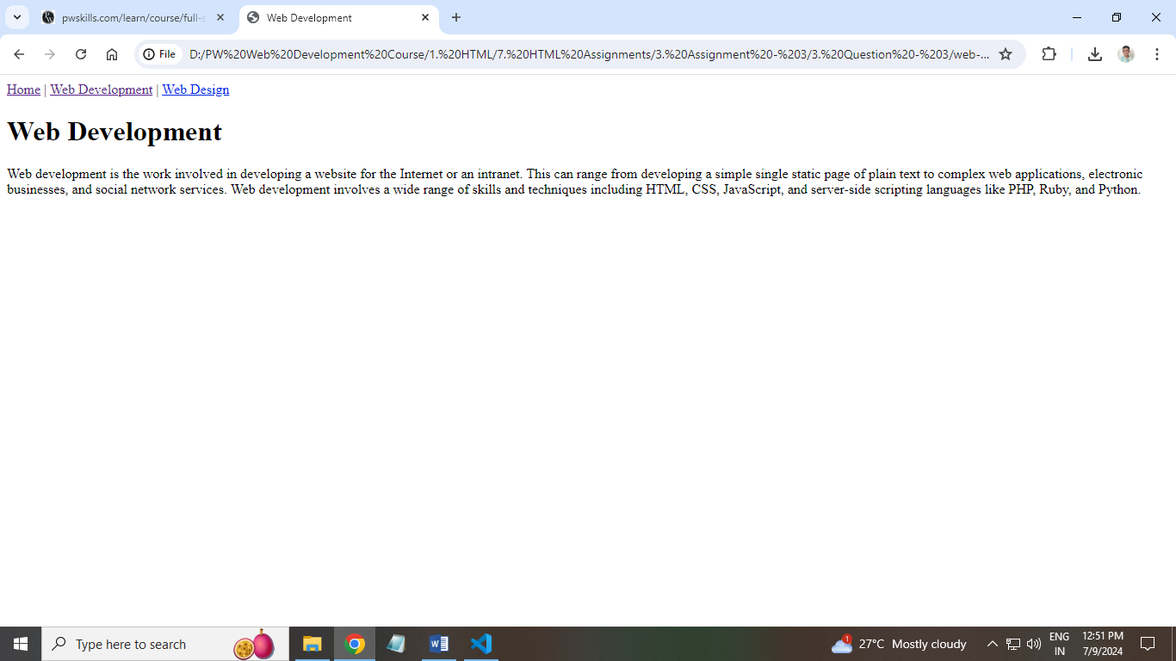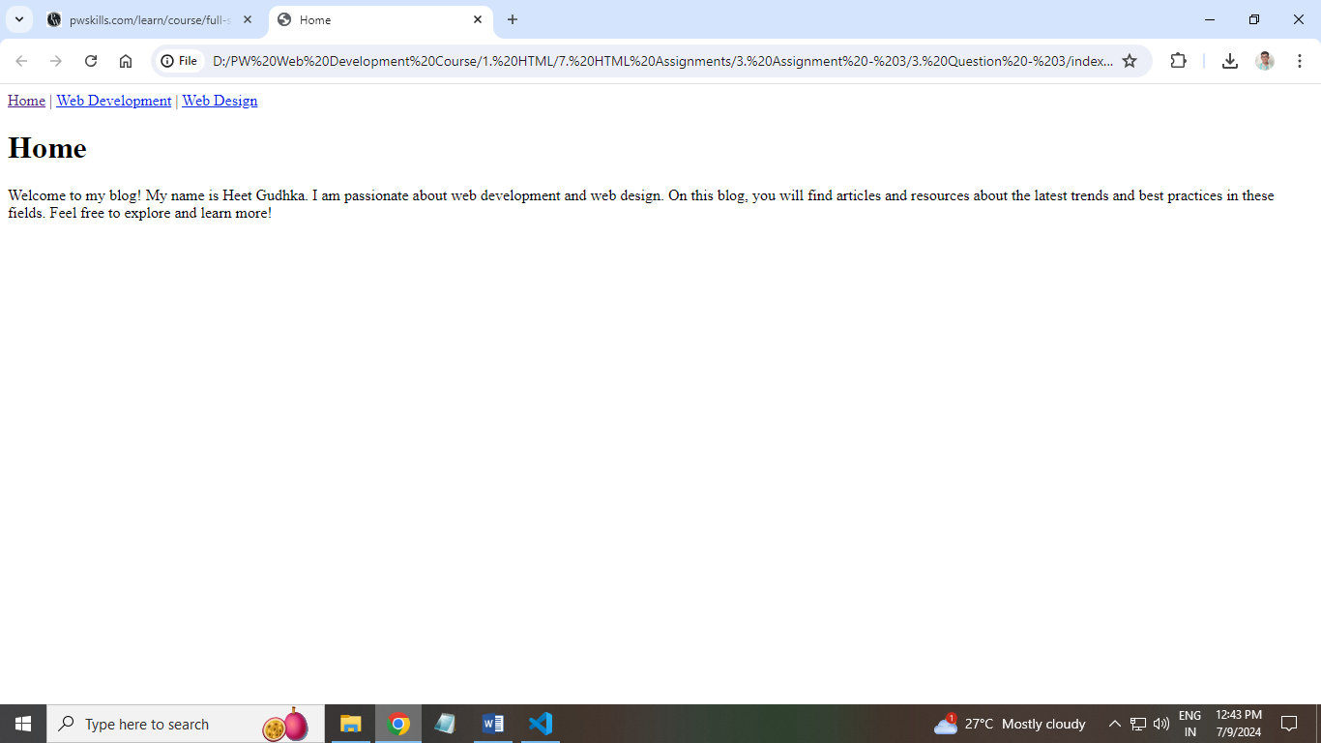

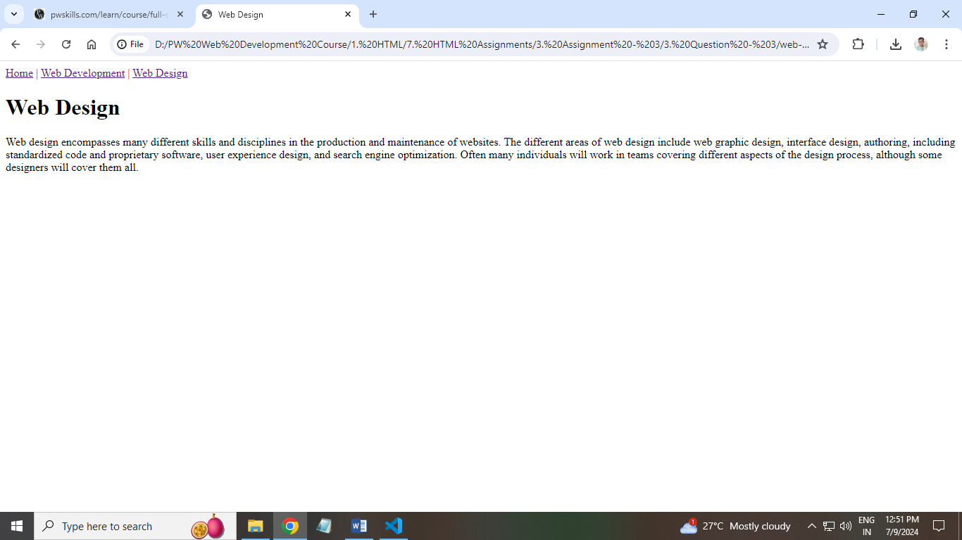**Ans: HTML Code:**

**index.html:**

**<!DOCTYPE html>**

**<html lang="en">**

**<head>**

**<meta charset="UTF-8">**

**<meta name="viewport" content="width=device-width, initial-scale=1.0">**

**<title>Home</title>**

**</head>**

**<body>**

**<! -- Navigation bar -->**

**<nav>**

**<! -- Link to Home page -->**

**<a href="index.html">Home</a> |**

**<! -- Link to Web Development page -->**

**<a href="web-development.html">Web Development</a> |**

**<! -- Link to Web Design page -->**

**<a href="web-design.html">Web Design</a>**

**</nav>**

**<! -- Main heading for the Home page -->**

**<h1>Home</h1>**

**<! -- Introduction paragraph -->**

**<p>Welcome to my blog! My name is Heet Gudhka. I am passionate about web development and web design. On this blog, you will find articles and resources about the latest trends and best practices in these fields. Feel free to explore and learn more!</p>**

**</body>**

**</html>**

**web-development.html**

**<!DOCTYPE html>**

**<html lang="en">**

**<head>**

**<meta charset="UTF-8">**

**<meta name="viewport" content="width=device-width, initial-scale=1.0">**

**<title>Web Development</title>**

**</head>**

**<body>**

**<! -- Navigation bar -->**

**<nav>**

**<! -- Link to Home page -->**

**<a href="index.html">Home</a> |**

**<! -- Link to Web Development page -->**

**<a href="web-development.html">Web Development</a> |**

**<! -- Link to Web Design page -->**

**<a href="web-design.html">Web Design</a>**

**</nav>**

**<! -- Main heading for the Web Development page -->**

**<h1>Web Development</h1>**

**<! -- Introduction paragraph -->**

**<p>Web development is the work involved in developing a website for the Internet or an intranet. This can range from developing a simple single static page of plain text to complex web applications, electronic businesses, and social network services. Web development involves a wide range of skills and techniques including HTML, CSS, JavaScript, and server-side scripting languages like PHP, Ruby, and Python.</p>**

**</body>**

**</html>**

**web-design.html**

**<!DOCTYPE html>**

**<html lang="en">**

**<head>**

**<meta charset="UTF-8">**

**<meta name="viewport" content="width=device-width, initial-scale=1.0">**

**<title>Web Design</title>**

**</head>**

**<body>**

**<! -- Navigation bar -->**

**<nav>**

**<! -- Link to Home page -->**

**<a href="index.html">Home</a> |**

**<! -- Link to Web Development page -->**

**<a href="web-development.html">Web Development</a> |**

**<! -- Link to Web Design page -->**

**<a href="web-design.html">Web Design</a>**

**</nav>**

**<! -- Main heading for the Web Design page -->**

**<h1>Web Design</h1>**

**<! -- Introduction paragraph -->**

**<p>Web design encompasses many different skills and disciplines in the production and maintenance of websites. The different areas of web design include web graphic design, interface design, authoring, including standardized code and proprietary software, user experience design, and search engine optimization. Often many individuals will work in teams covering different aspects of the design process, although some designers will cover them all.</p>**

**</body>**

**</html>**

1. **Create an ordered list of HTML tags. Each list item must include the tag name and some brief description of the information about the tag.**

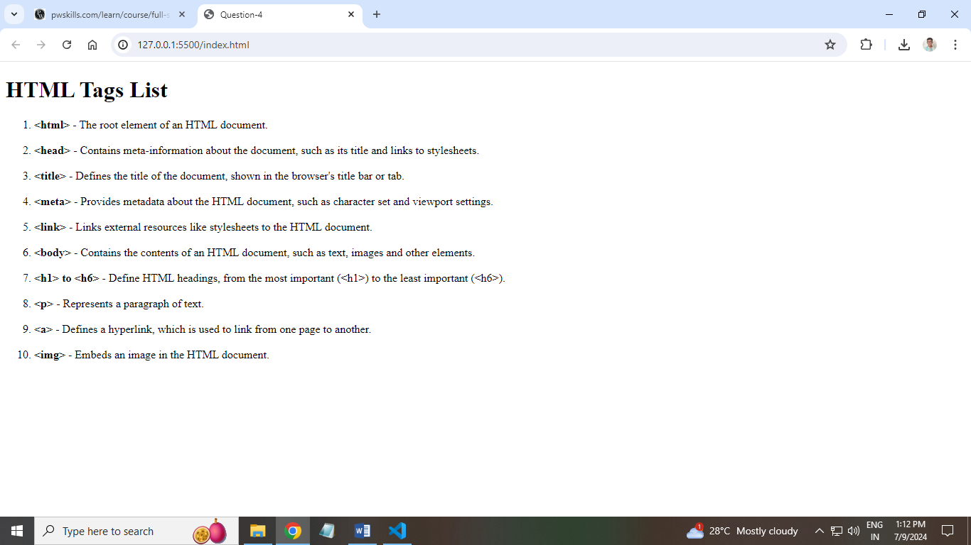**Ans: HTML Code:**

**<!DOCTYPE html>**

**<html lang="en">**

**<head>**

**<meta charset="UTF-8">**

**<meta name="viewport" content="width=device-width, initial-scale=1.0">**

**<title>Question-4</title>**

**</head>**

**<body>**

**<h1>HTML Tags List</h1>**

**<ol>**

**<! -- List of HTML tags -->**

**<! -- HTML Tag -->**

**<li>**

**<strong>&lt;html&gt;</strong> - The root element of an HTML document.**

**</li>**

**<br>**

**<! -- head tag -->**

**<li>**

**<strong>&lt;head&gt;</strong> - Contains meta-information about the document, such as its title and links to stylesheets.**

**</li>**

**<br>**

**<! -- title tag -->**

**<li>**

**<strong>&lt;title&gt;</strong> - Defines the title of the document, shown in the browser's title bar or tab.**

**</li>**

**<br>**

**<!-- meta tag -->**

**<li>**

**<strong>&lt;meta&gt;</strong> - Provides metadata about the HTML document, such as character set and viewport settings.**

**</li>**

**<br>**

**<!-- link tag -->**

**<li>**

**<strong>&lt;link&gt;</strong> - Links external resources like stylesheets to the HTML document.**

**</li>**

**<br>**

**<!-- body tag -->**

**<li>**

**<strong>&lt;body&gt;</strong> - Contains the contents of an HTML document, such as text, images and other elements.**

**</li>**

**<br>**

**<!-- heading tags -->**

**<li>**

**<strong>&lt;h1&gt; to &lt;h6&gt;</strong> - Define HTML headings, from the most important (&lt;h1&gt;) to the least important (&lt;h6&gt;).**

**</li>**

**<br>**

**<!-- paragraph tag -->**

**<li>**

**<strong>&lt;p&gt;</strong> - Represents a paragraph of text.**

**</li>**

**<br>**

**<!-- anchor tag -->**

**<li>**

**<strong>&lt;a&gt;</strong> - Defines a hyperlink, which is used to link from one page to another.**

**</li>**

**<br>**

**<!-- image tag -->**

**<li>**

**<strong>&lt;img&gt;</strong> - Embeds an image in the HTML document.**

**</li>**

**</ol>**

**</body>**

**</html>**

1. **Create a description list of full stack web development tech stack, using the <dl> tag. Each term should be a tech stack name and each description should be a brief explanation of what the tech stack is used for.**

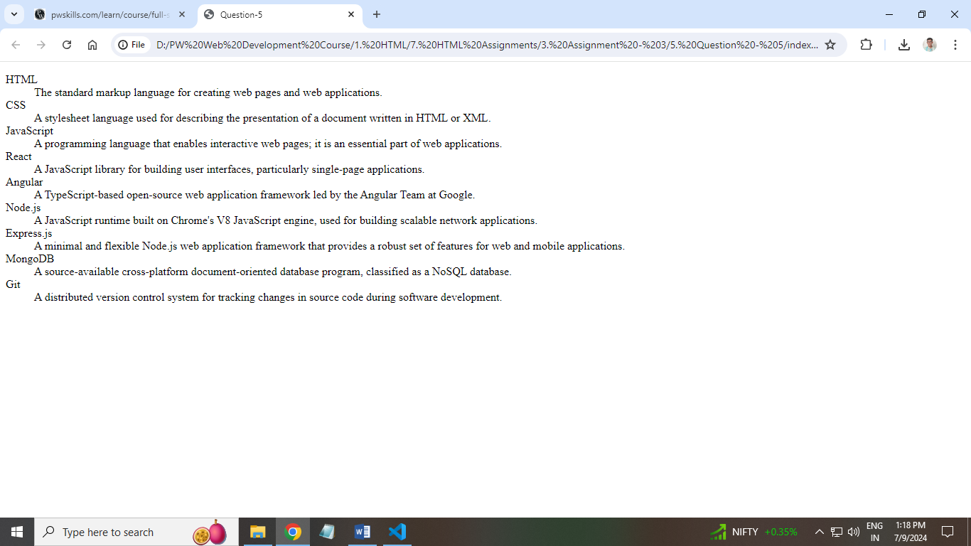**Ans: HTML Code:**

**<!DOCTYPE html>**

**<html lang="en">**

**<head>**

**<meta charset="UTF-8">**

**<meta name="viewport" content="width=device-width, initial-scale=1.0">**

**<title>Question-5</title>**

**</head>**

**<body>**

**<!-- Description List -->**

**<dl>**

**<!-- Description Terms -->**

**<dt>HTML</dt>**

**<!-- Description Definition -->**

**<dd>The standard markup language for creating web pages and web applications.</dd>**

**<dt>CSS</dt>**

**<dd>A stylesheet language used for describing the presentation of a document written in HTML or XML.</dd>**

**<dt>JavaScript</dt>**

**<dd>A programming language that enables interactive web pages; it is an essential part of web applications.</dd>**

**<dt>React</dt>**

**<dd>A JavaScript library for building user interfaces, particularly single-page applications.</dd>**

**<dt>Angular</dt>**

**<dd>A TypeScript-based open-source web application framework led by the Angular Team at Google.</dd>**

**<dt>Node.js</dt>**

**<dd>A JavaScript runtime built on Chrome's V8 JavaScript engine, used for building scalable network**

**applications.</dd>**

**<dt>Express.js</dt>**

**<dd>A minimal and flexible Node.js web application framework that provides a robust set of features for web and mobile applications.</dd>**

**<dt>MongoDB</dt>**

**<dd>A source-available cross-platform document-oriented database program, classified as a NoSQL database.</dd>**

**<dt>Git</dt>**

**<dd>A distributed version control system for tracking changes in source code during software development.</dd>**

**</dl>**

**</body>**

**</html>**

1. **Create an ordered list of the full stack web development tech stack HTML, CSS, and JS. For each tech stack, create a table that lists the tech stack name, its primary use cases, and some key features or benefits. Below is a reference image.**

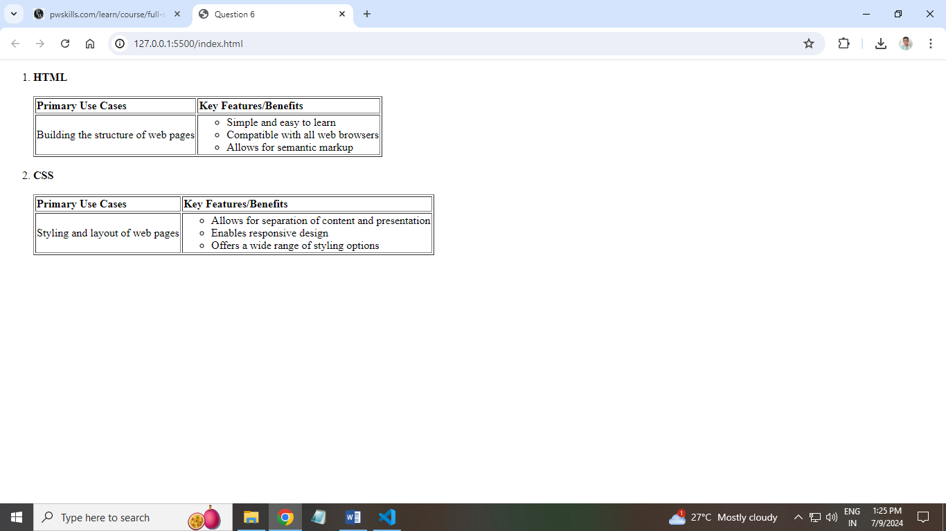**Ans: HTML Code:**

**<!DOCTYPE html>**

**<html lang="en">**

**<head>**

**<meta charset="UTF-8">**

**<meta name="viewport" content="width=device-width, initial-scale=1.0">**

**<title>Question 6</title>**

**</head>**

**<body>**

**<!-- Start of the ordered list -->**

**<ol>**

**<!-- HTML Section -->**

**<li><b>HTML</b></li> <br>**

**<!-- Start of the table for HTML -->**

**<table border="1" width="38.5%">**

**<!-- Table header row -->**

**<tr>**

**<th align="left">Primary Use Cases</th>**

**<th align="left">Key Features/Benefits</th>**

**</tr>**

**<!-- Table row with data -->**

**<tr>**

**<!-- Cell for primary use cases -->**

**<td>Building the structure of web pages</td>**

**<!-- Cell for key features/benefits, spanning three rows -->**

**<td rowspan="3">**

**<ul>**

**<li>Simple and easy to learn</li>**

**<li>Compatible with all web browsers</li>**

**<li>Allows for semantic markup</li>**

**</ul>**

**</td>**

**</tr>**

**</table>**

**<br>**

**<!-- CSS Section -->**

**<li><b>CSS</b></li> <br>**

**<!-- Start of the table for CSS -->**

**<table border="1" width="44.2%">**

**<!-- Table header row -->**

**<tr>**

**<th align="left">Primary Use Cases</th>**

**<th align="left">Key Features/Benefits</th>**

**</tr>**

**<!-- Table row with data -->**

**<tr>**

**<!-- Cell for primary use cases -->**

**<td>Styling and layout of web pages</td>**

**<!-- Cell for key features/benefits, spanning three rows -->**

**<td rowspan="3">**

**<ul>**

**<li>Allows for separation of content and presentation</li>**

**<li>Enables responsive design</li>**

**<li>Offers a wide range of styling options</li>**

**</ul>**

**</td>**

**</tr>**

**</table>**

**</ol>**

**</body>**

**</html>**

1. **Build a complex nested list structure representing a multi-level table of contents. Use unordered lists (<ul>) and list items (<li>) with inline-block styling to create a structured layout. Apply formatting tags to enhance the presentation of list items.**

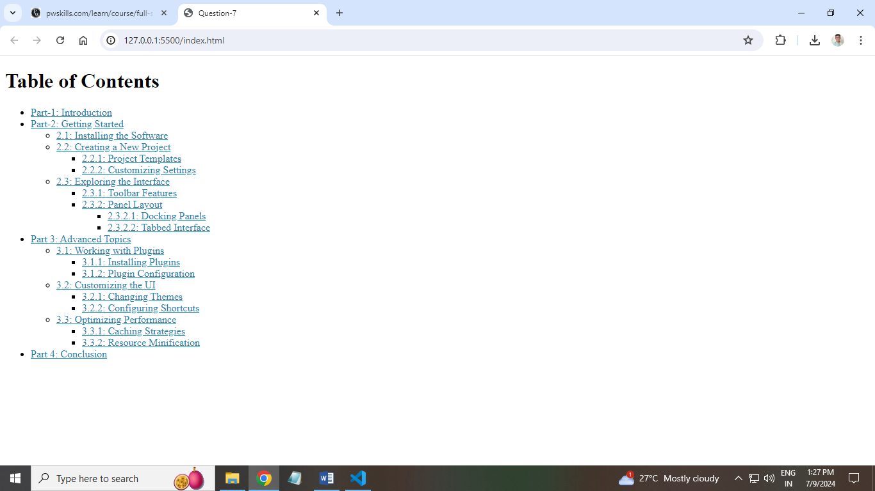**Ans: HTML Code:**

**<!DOCTYPE html>**

**<html lang="en">**

**<head>**

**<meta charset="UTF-8">**

**<meta name="viewport" content="width=device-width, initial-scale=1.0">**

**<title>Question-7</title>**

**</head>**

**<body>**

**<h1>Table of Contents</h1>**

**<ul>**

**<!-- Main list item for Part 1 -->**

**<li><a href="#" style="color: rgb(23, 134, 179);">Part-1: Introduction</a></li>**

**<!-- Main list item for Part 2 -->**

**<li><a href="#" style="color: rgb(23, 134, 179);">Part-2: Getting Started</a></li>**

**<!-- Nested list for Part 2 with a circle bullet style -->**

**<ul style="list-style-type: circle;">**

**<!-- Sub-item under Part 2 -->**

**<li><a href="#" style="color: rgb(23, 134, 179);">2.1: Installing the Software</a></li>**

**<!-- Sub-item under Part 2 -->**

**<li><a href="#" style="color: rgb(23, 134, 179);">2.2: Creating a New Project</a></li>**

**<!-- Nested list under 2.2 with a square bullet style -->**

**<ul style="list-style-type: square;">**

**<!-- Sub-item under 2.2 -->**

**<li><a href="#" style="color: rgb(23, 134, 179);">2.2.1: Project Templates</a></li>**

**<!-- Sub-item under 2.2 -->**

**<li><a href="#" style="color: rgb(23, 134, 179);">2.2.2: Customizing Settings</a></li>**

**</ul>**

**<!-- Sub-item under Part 2 -->**

**<li><a href="#" style="color: rgb(23, 134, 179);">2.3: Exploring the Interface</a></li>**

**<!-- Nested list under 2.3 with a square bullet style -->**

**<ul style="list-style-type: square;">**

**<!-- Sub-item under 2.3 -->**

**<li><a href="#" style="color: rgb(23, 134, 179);">2.3.1: Toolbar Features</a></li>**

**<!-- Sub-item under 2.3 -->**

**<li><a href="#" style="color: rgb(23, 134, 179);">2.3.2: Panel Layout</a></li>**

**<!-- Nested list under 2.3.2 with a square bullet style -->**

**<ul style="list-style-type: square;">**

**<!-- Sub-item under 2.3.2 -->**

**<li><a href="#" style="color: rgb(23, 134, 179);">2.3.2.1: Docking Panels</a></li>**

**<!-- Sub-item under 2.3.2 -->**

**<li><a href="#" style="color: rgb(23, 134, 179);">2.3.2.2: Tabbed Interface</a></li>**

**</ul>**

**</ul>**

**</ul>**

**<!-- Main list item for Part 3 -->**

**<li><a href="#" style="color: rgb(23, 134, 179);">Part 3: Advanced Topics</a></li>**

**<!-- Nested list for Part 3 with a circle bullet style -->**

**<ul style="list-style-type: circle;">**

**<!-- Sub-item under Part 3 -->**

**<li><a href="#" style="color: rgb(23, 134, 179);">3.1: Working with Plugins</a></li>**

**<!-- Nested list under 3.1 -->**

**<ul>**

**<!-- Sub-item under 3.1 -->**

**<li><a href="#" style="color: rgb(23, 134, 179);">3.1.1: Installing Plugins</a></li>**

**<!-- Sub-item under 3.1 -->**

**<li><a href="#" style="color: rgb(23, 134, 179);">3.1.2: Plugin Configuration</a></li>**

**</ul>**

**<!-- Sub-item under Part 3 -->**

**<li><a href="#" style="color: rgb(23, 134, 179);">3.2: Customizing the UI</a></li>**

**<!-- Nested list under 3.2 with a square bullet style -->**

**<ul style="list-style-type: square;">**

**<!-- Sub-item under 3.2 -->**

**<li><a href="#" style="color: rgb(23, 134, 179);">3.2.1: Changing Themes</a></li>**

**<!-- Sub-item under 3.2 -->**

**<li><a href="#" style="color: rgb(23, 134, 179);">3.2.2: Configuring Shortcuts</a></li>**

**</ul>**

**<!-- Sub-item under Part 3 -->**

**<li><a href="#" style="color: rgb(23, 134, 179);">3.3: Optimizing Performance</a></li>**

**<!-- Nested list under 3.3 -->**

**<ul>**

**<!-- Sub-item under 3.3 -->**

**<li><a href="#" style="color: rgb(23, 134, 179);">3.3.1: Caching Strategies</a></li>**

**<!-- Sub-item under 3.3 -->**

**<li><a href="#" style="color: rgb(23, 134, 179);">3.3.2: Resource Minification</a></li>**

**</ul>**

**</ul>**

**<!-- Main list item for Part 4 -->**

**<li><a href="#" style="color: rgb(23, 134, 179);">Part 4: Conclusion</a></li>**

**</ul>**

**</body>**

**</html>**